Patton
37
MILITARY
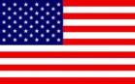
1st US 3rd US
Shuffle Late Deck Cards into Draw Deck
AIR POWER
Jabos: +1 3rd US
RESOURCES

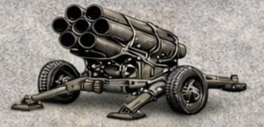
2 x Nebelwerfers * Lose 1

*Each marker can be immediately deployed to map or placed in Strategic Reserve box

ORDERS: 2 Actions
+1 Attack Strength 1st US ARMY
+2 Patton 3rd US ARMY
Following the Normandy invasion, Patton was placed in command of the U.S. Third Army, which was on the extreme right (west) of the Allied land forces. Beginning at noon on August 1, 1944, he led this army during the late stages of Operation Cobra, the breakout from earlier slow fighting in the Normandy hedgerows. The Third Army simultaneously attacked west (into Brittany), south, east towards the Seine, and north, assisting in trapping several hundred thousand German soldiers in the Chambois pocket, between Falaise and Argentan.

